Software Blueprint
Manufacturing ERP & Quality Management SaaS
PaintKing Solutions Pvt. Ltd. — Industrial Spray Painting Operations
Prepared for: Gurprit Sir (MD) · Prepared by: Avinash, Avi Digital Marketing

1. Executive Summary
PaintKing Solutions Pvt. Ltd. is transitioning from manual, paper-based shop-floor operations (logbooks, paper forms, unlinked spreadsheets across 13 formats) to a single cloud-based Manufacturing ERP + Quality Management SaaS.
This blueprint consolidates everything finalized so far — business problems, the 13 real paper formats mapped to system modules, the 5-stage QC chain, the confirmed role/login structure, the full RBAC permission matrix, and system-enforced approval chains — into one build-ready reference.

2. Core Business Problems
- Unorganized data & no real-time visibility — 13+ separate paper formats with no linkage between them.
- Inter-department material discrepancies / shrinkage — Job Card Issue vs Return and GRN Invoiced vs Received quantities reconciled manually.
- No strict SLA/deadline enforcement — Job Cards capture Lead Time but nothing enforces it.
- Disjointed Quality Control — 5 separate inspection stages (IQC, FPA, IPQC, OQC, PDI) with no shared defect taxonomy or batch linkage.
- Low MNC vendor audit scores — the 13-section (A–M), ~100-question audit questionnaire is filled manually per cycle with no system-backed evidence.

3. System Architecture
The platform is organized into 5 modules (A–E) sitting on a shared data layer, as shown below.
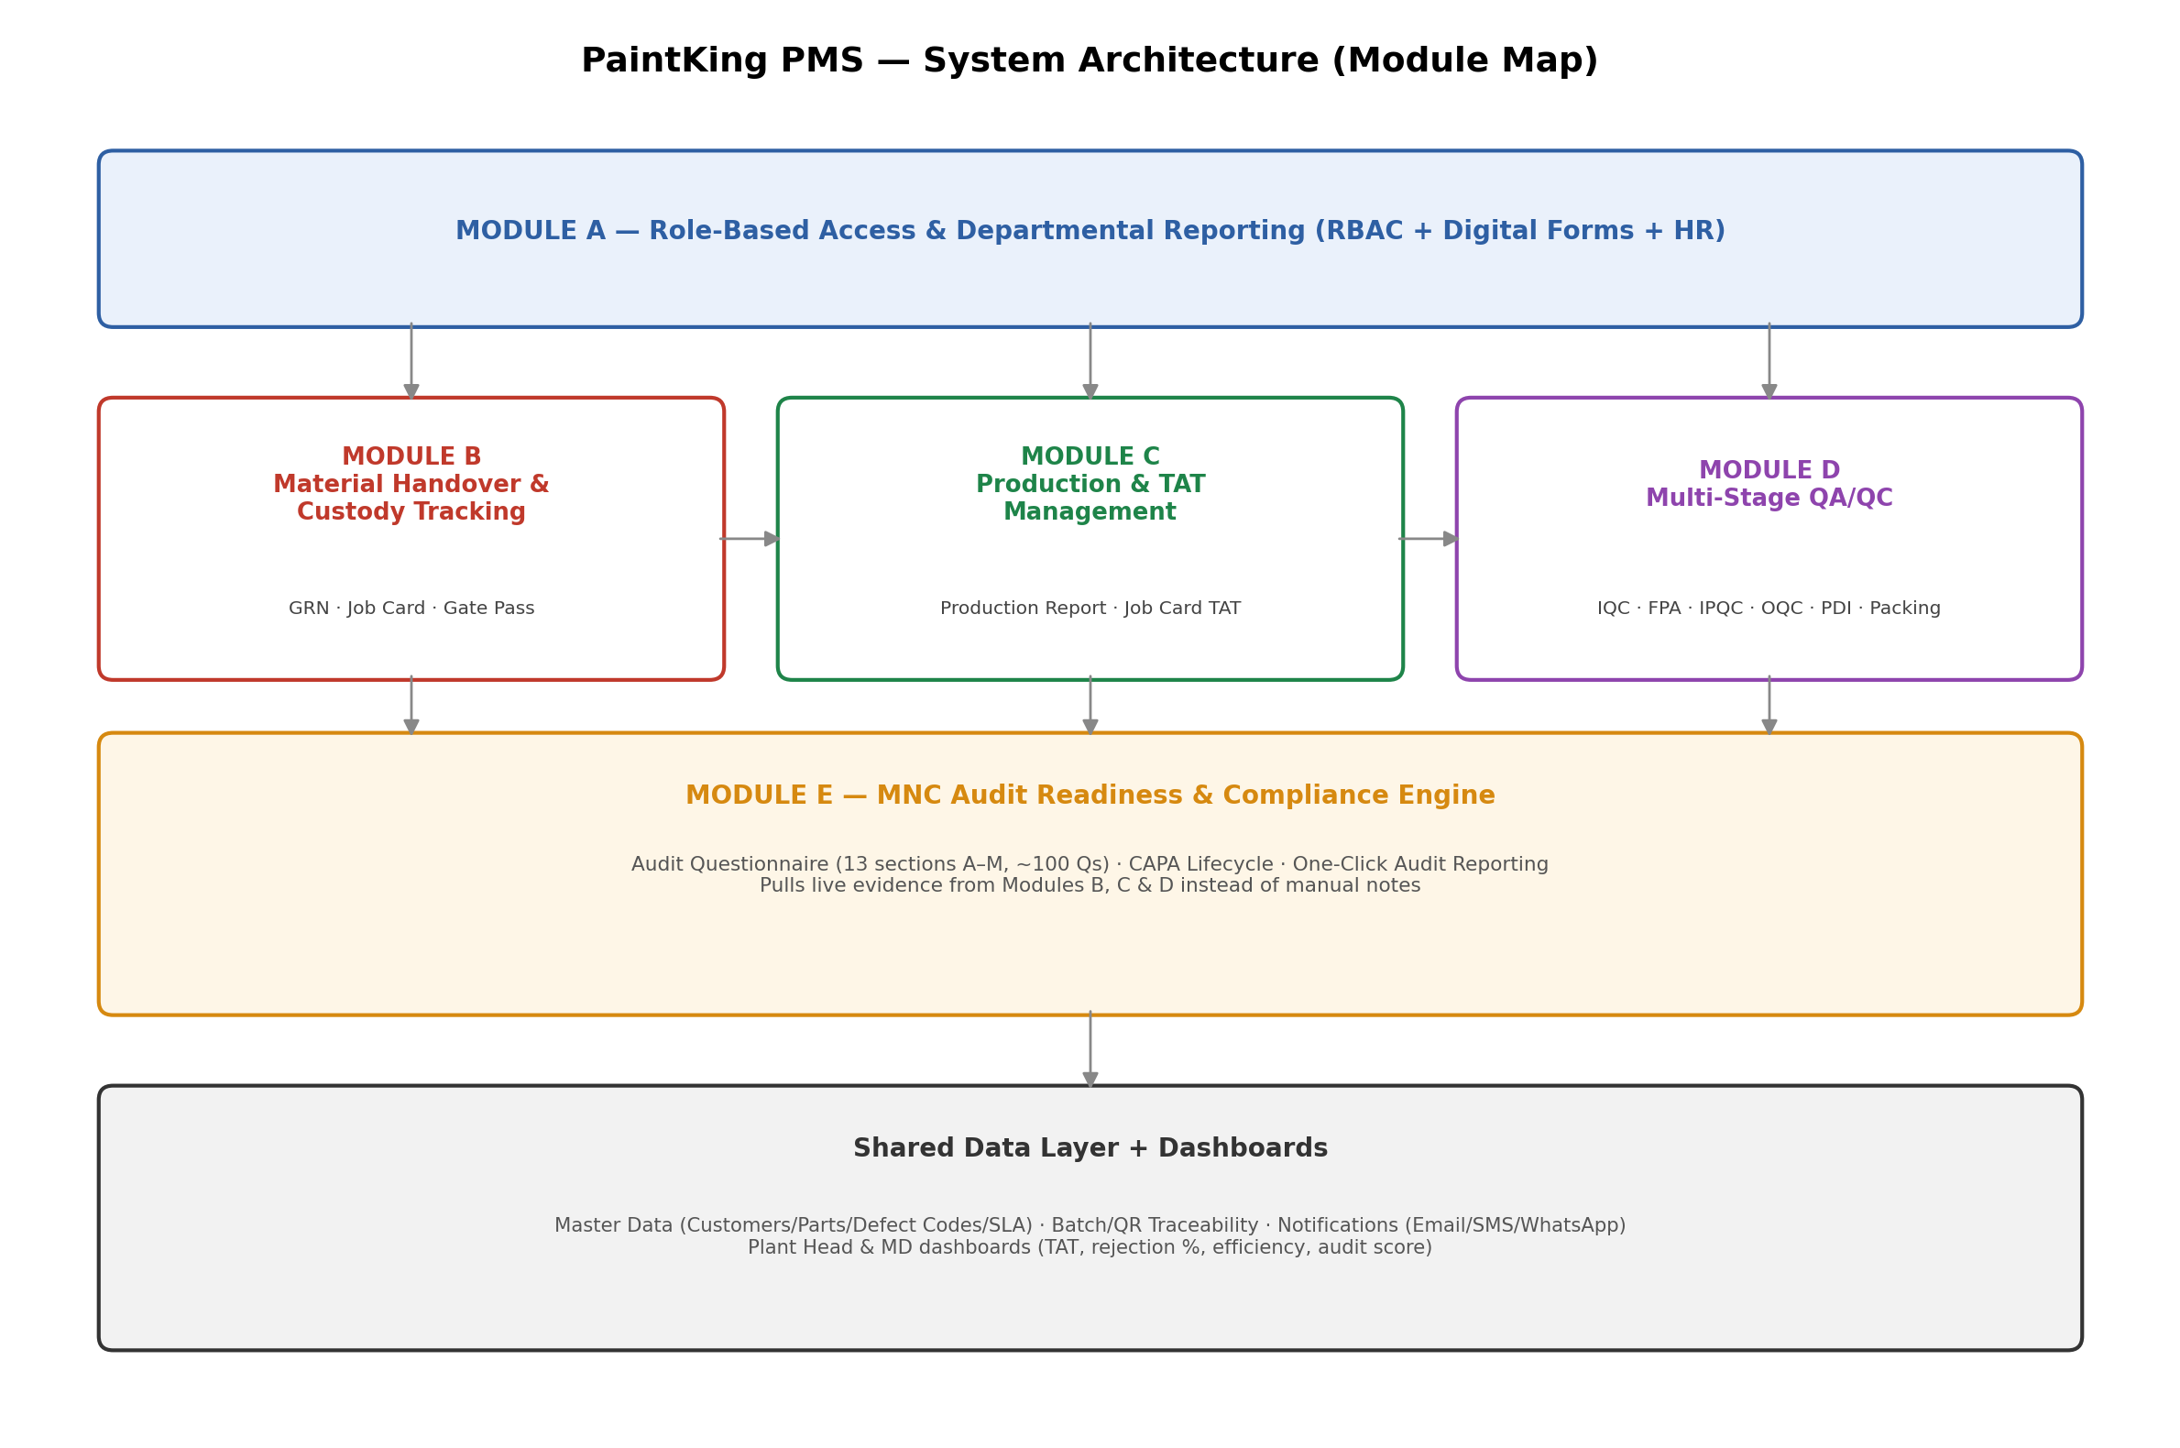

4. Source Document Inventory
Every module is built directly on PaintKing's own existing paper formats — not a generic template — so field names, structure, and bilingual (English/Hindi) labels carry straight through.
Existing Paper Format | Maps to Module | Purpose
Production Report / Production Offering Report | Module C | Daily plant-wise output vs target, rejection, efficiency
Job Card (Cubic Paint Frame) | Module B, C | Issue/Return chain of custody + process-stage quantities
GRN Copy | Module B | Inward material receipt & reconciliation
IQC Report | Module D.1 | Incoming Quality Inspection
FPA Report | Module D.3 (gate) | First Part Approval before a production run starts
IPQC | Module D.3 | In-Process Quality Control, shift-wise
OQC Report | Module D.4 | Outgoing Quality Control on finished lots
PDI Report | Module D.5 | Pre-Dispatch Inspection
Packing Slip | Module D.5 | Box-level packing record
FG Offer Report | Module D.4 | Finished-goods lot offered for OQC, box-wise
Leave Format | Module A (HR) | Employee leave application
Gate Pass | Module B | Material/vehicle gate movement — owned by Security
Audit Questionnaire (A–M, Eng+Hindi) | Module E | Live MNC audit compliance framework

5. End-to-End Process Flow
The diagram below shows the batch/job-card lifecycle from inward material to dispatch. Red stages are QC gates — a batch cannot move forward without that stage's sign-off.
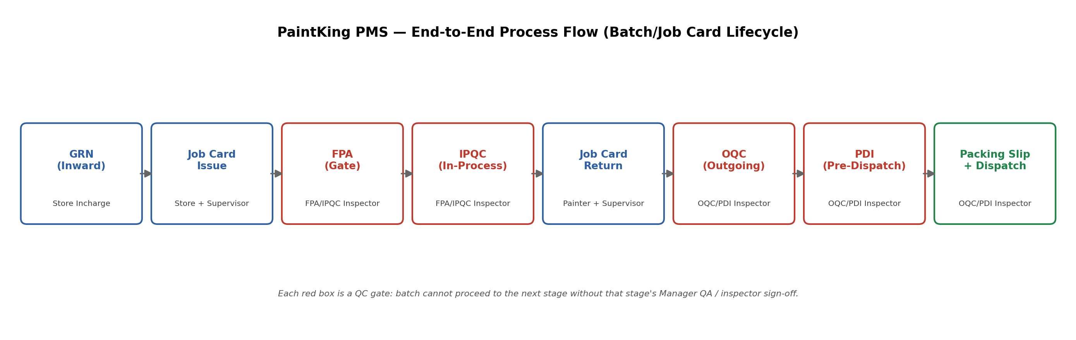

6. Functional Modules

Module A — Role-Based Access & Departmental Reporting
- RBAC dashboards for every confirmed role (see Section 8).
- Digital forms for all 13 paper formats, preserving exact field labels and bilingual text.
- HR sub-module: Leave Application digitized — Employee/Father Name, Department, Designation, Addresses, Reason, Leave On/Off Date, Total Leave Days, with Employee → Dept. Incharge → HR digital approval chain.
- Automated anomaly & error escalation — real-time alerts on critical errors, delays, threshold violations.

Module B — Digital Material Handover & Custody Tracking
- GRN: GRN No., Date, Vehicle No., Supplier, Invoice/Challan No. & Date, Received Date, Transport Name, line items (Part Code, Description, Invoiced Qty, Actual Received, Short-Excess, Ok By IQC, Rej. Qty, Remark). System auto-computes Short-Excess and blocks closure until Store + IQC + Approver all sign off.
- Job Card two-way handover: Initial Process (Painter, W.No., Issue Date/Time, Customer, Lead Time, Dept., Issue Material Details) vs Final Process (Return Material Description, Return Painter, Return Date/Time, Return Ok Qty, Return Rejection Qty, Checking Person). System flags variance and requires a reconciliation code before closing.
- Job Card process-stage tracking: Base Coat / Dipping / Final Lacquer, each with Total/Ok/Rejection Qty.
- Gate Pass — fully owned end-to-end by Security; visible for reference to Store Incharge and Plant Head/MD only.
- Batch/Lot tracking via Barcode/QR linking GRN → Job Card → IQC/FPA/IPQC/OQC/PDI → Packing Slip.

Module C — Job Card Production Management & Deadline Tracking
- Production Report: Plant, Painter Name, Customer, Model, Colour, Target, FPA Time, Achieved Qty, Efficiency %, rolled up to an overall efficiency dashboard.
- Production Offering Report: Doc No., Date, Plant, Painter, Customer, Job Model, Colour, Target, Achieved, In-Process Rejection, Final Rejection, Problem, sign-off chain (Prepared/Checked/QA/Approved).
- Standard Operating Time & SLA Engine: Job Card Lead Time becomes a system-enforced TAT with auto-flagging on breach.
- Operator accountability: start/pause/completion timestamps tied to Painter Name and W.No.
- Bottleneck escalation dashboard for near-deadline/overdue job cards, notifying Prod. Supervisor.

Module D — Multi-Stage Quality Assurance (QA/QC)
All five stages share a common structure: header (Report No., Date/Time, Part details, Customer, Work Order No., Batch info) + parameters table (Parameter, Specification, Measurement Technique, Result) + sign-off (Prepared By: Inspector / Approved By: Manager QA).
- IQC — Incoming Quality Inspection: Packing/Box Condition, Traceability, Quantity, Physical Inspection, Conductivity, Adhesion, Delta Value (Major/Critical tags). Includes Sample Size/Pass/Reject/Rejection % and Root Cause/Corrective/Preventive Action block feeding CAPA.
- FPA — First Part Approval: mandatory gate before a production run starts. Visual Test, Adhesion Test, Delta Value Test across up to 5 samples. Ends with Painter + Prod. Incharge acceptance.
- IPQC — In-Process QC: same parameter set as FPA, logged per shift across 8 time windows (8:00–11:00 through 5:00–8:00).
- OQC — Outgoing QC: Damage, Scratch, Sink Mark, Short Fill, Bubble, Pin Mark, Dust Spot, Over Paint, Paint Missing, Colour, Overall Finishing + Delta Value Test. Feeds the FG Offer Report (box-level ledger).
- PDI — Pre-Dispatch Inspection: Box/Bin Condition, Polybag Condition, Identification, Short/Excess, Painting Defects, Adhesion, Delta Values. Final artifact: Packing Slip, auto-generated once PDI passes.
- Automated Rework/Scrap Workflow: any rejection at any stage auto-creates a defect-coded ticket with cost roll-up.

Module E — MNC Audit Readiness & Compliance Engine
- Live Audit Questionnaire structure: 13 sections (A–M), bilingual English/Hindi, ~100 questions — A. Plant & Process Scope, B. Incoming Material & Stores, C. Paint Preparation & Mixing, D. Pre-treatment/Cleaning/Loading, E. Painting Process & Parameters, F. Start-up/FPA, G. In-process & Final QC, H. Traceability/Packing/Dispatch, I. Rejection/Rework/NC Material, J. Customer Complaints/CAPA/Change Control, K. Machines/Maintenance/Calibration, L. SPC/Capability/Training/Documents, M. Internal Audit & Management Review.
- Each answer captures actual current practice, Yes/No/NA, actual value/range, and the linked live record — so answers pull from real Module B/C/D data instead of manual notes.
- CAPA Lifecycle (Section J): Root Cause Analysis (5-Why/Fishbone) with sign-off tracking.
- One-Click Audit Reporting: full batch traceability + calibration records + filled questionnaire, exported on demand.

7. Confirmed Role / Login Structure
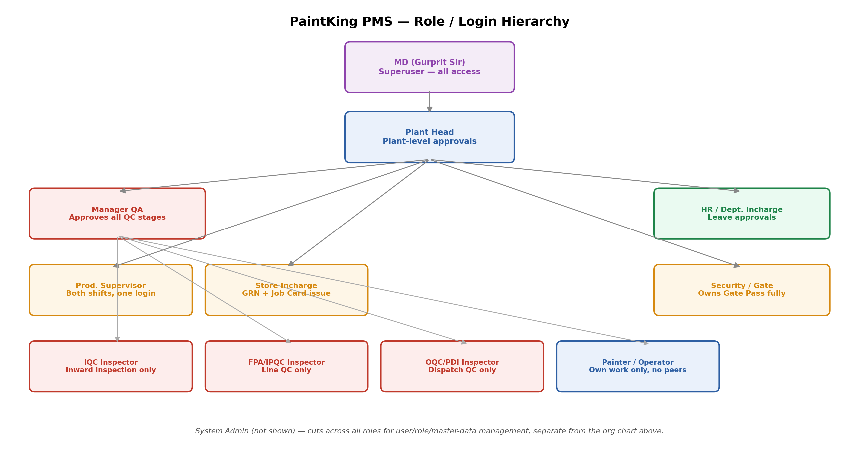

Roles finalized
Role | Scope
Store Incharge | GRN, Job Card material issue
Painter / Operator | Own Job Cards, own FPA acceptance, own output only — no visibility into other painters' data or rejection %
Prod. Supervisor | One login covering both shifts (not split into Shift A/B)
IQC Inspector | Separate person — inward inspection only
FPA/IPQC Inspector | Separate person — line/in-process QC only
OQC/PDI Inspector | Separate person — outgoing/dispatch QC only
Manager QA | Approves/overrides all 3 QC inspector streams
HR | Leave approvals only
Dept. Incharge | Departmental leave approval
Security / Gate | Owns Gate Pass end-to-end, independently
Plant Head | Plant-level operational approvals, separate login from MD
MD (Gurprit Sir) | Superuser — full access to every module, record, and role's queue
System Admin | User management, role config, master data — not on any paper form

8. RBAC Permission Matrix
Legend: V = View · C = Create · E = Edit · A = Approve/Sign-off · — = No access

Material & Store Modules
Module | Store Incharge | Prod. Supervisor | IQC Inspector | Security | Plant Head | MD
GRN (Inward) | V,C,E | V | V,A | — | V,A | V,A
Job Card — Issue | V,C,E | V,C,E | V | — | V | V
Job Card — Return | V,A | V,A | V | — | V | V
Gate Pass | V | V | — | V,C,E,A | V | V

Production Modules
Module | Painter | Prod. Supervisor | Manager QA | Plant Head | MD
Production Report | V (own) | V,C,E | — | V,A | V,A
Production Offering Report | V,C,E (own) | V,C,E,A | V,A | V,A | V,A

Quality Modules
Module | IQC Inspector | FPA/IPQC Inspector | OQC/PDI Inspector | Manager QA | Painter | Plant Head/MD
IQC Report | V,C,E,A | — | — | V | — | V
FPA Report | — | V,C,E,A | — | V,A | V,A (own) | V
IPQC | — | V,C,E,A | — | V,A | V (own) | V
OQC Report | — | — | V,C,E,A | V,A | — | V
PDI Report | — | — | V,C,E,A | V,A | — | V
Packing Slip | — | — | V,A | V | V,C (own) | V

HR, Audit & Admin Modules
Module | HR | Dept. Incharge | Section Owners (QC Inspectors) | Plant Head | MD | System Admin
Leave Format | V,A | V,A | — | V | V | V,C,E,A
Audit Questionnaire (A–M) | — | — | V,E (own sections) | V | V,A (final) | V
CAPA / Rework-Scrap | — | — | V,C,E,A (own stage) | V | V | V
User & Role Management | — | — | — | V (plant users) | V,C,E,A | V,C,E,A

9. System-Enforced Approval Chains
- GRN: Store Incharge (create) → IQC Inspector (Ok By IQC qty) → Plant Head/MD (final approve) → material released for Job Card issue.
- Job Card: Store Incharge (issue) → Prod. Supervisor (approve issue) → Painter (executes) → Painter/Checking Person (return) → Prod. Supervisor (approve return) → variance reconciliation required if Issue Qty ≠ Return Ok + Rejection Qty.
- FPA (gate): FPA/IPQC Inspector (inspect) → Painter (acceptance) → Prod. Incharge (acceptance) → Manager QA (approve) → only then can Production Report/Job Card log output for that batch.
- IQC / IPQC / OQC / PDI: relevant stage Inspector (Prepared By) → Manager QA (Approved By) — batch cannot move to next stage without approval. Each stage routes to its own inspector's queue, not a shared QC inbox.
- Rejection at any QC stage: auto-creates CAPA ticket → owning-stage Inspector (root cause) → Manager QA (approve corrective/preventive action) → closed.
- Leave: Employee (apply) → Dept. Incharge (approve) → HR (approve) → closed.
- Audit Questionnaire: each section owner fills their section → MD reviews and signs "Reviewed by" → locked for that audit cycle.
- Gate Pass: Security issues and closes independently — visible for reference only to Store Incharge and Plant Head/MD.

10. Technical & Non-Functional Requirements
- Platform: Responsive Web Application — desktop for QA/Management, mobile/tablet for shop floor.
- Architecture: Secure Multi-tenant or Enterprise Single-tenant Cloud (e.g., AWS/GCP).
- Notifications: transactional email/SMS/WhatsApp for TAT breach, quantity variance, rejection spikes.
- Input baseline: schema mapped directly from the 13 existing formats — field names and bilingual labels preserved.
- Language: bilingual English/Hindi UI for shop-floor-facing forms (Job Card, Leave Format, Audit Questionnaire).
- Build approach: custom build on this blueprint (evaluated against ERPNext/MIE Trak Pro for benchmarking only — neither maps cleanly to PaintKing's exact forms without heavy rework).

11. Open Items
- Gate Pass field structure still to be finalized with Security team (current source sheet has no defined fields).

12. Expected Outcome
A unified, paperless manufacturing execution system — built on PaintKing's own real forms and confirmed role structure rather than a generic template — that eliminates unaccounted product loss, enforces painter productivity and deadlines, establishes airtight quality gates across IQC/FPA/IPQC/OQC/PDI, and turns the existing 13-section audit questionnaire into a system-backed, one-click compliance report for MNC vendor audits.

Appendix A — Complete Field-Level Specification (Every Form, Every Field)
This appendix lists every field found on PaintKing's 13 real paper formats, exactly as they appear, so nothing gets missed or re-interpreted when the digital forms are built. Fields marked (computed) should be system-calculated, not manually entered.

A.1 — Production Report (PROD)
Field | Type / Notes
Plant | Dropdown — plant/location
Painter Name | Dropdown — linked to Painter/Operator login
Customer | Dropdown — linked to Master Data
Model | Text/Dropdown — linked to Part Master
Colour | Text/Dropdown
Target | Number — expected qty
FPA Time | Time — pulled from linked FPA record
Achieved Qty | Number — actual produced
Effi. (Efficiency %) | (computed) = Achieved / Target × 100
Remark's | Free text
Production Effi Overall | (computed) — rollup across all entries for the day/plant
Checked By | Signature/approval — Prod. Supervisor
Approved By | Signature/approval — Plant Head/MD

A.2 — Job Card (Cubic Paint Frame)

Initial Process (Issue side)
Field | Type / Notes
Painter Name | Dropdown — linked to Painter login
W.No. (Worker Number) | Text/ID — links Painter to shop-floor ID
Issue Date | Date
Issue Time | Time
Customer | Dropdown
Lead Time | Number (hours) — becomes system-enforced TAT
Dept. | Dropdown — department issuing

Issue Material Details (line items)
Field | Type / Notes
Item Description | Text/dropdown — Part Master
Qty | Number
Colour | Text/dropdown
UOM | Dropdown (Pcs/Kg/Ltr etc.)
Remark | Free text

Final Process (Return side)
Field | Type / Notes
Return Material Description | Text — should auto-fill from Issue side
Return Painter Name | Dropdown — usually same as Issue Painter
Return Date | Date
Return Time | Time
Return Ok Qty | Number
Return Rejection Qty | Number
Checking Person | Dropdown — Prod. Supervisor or QC

Process Stage Table (per batch)
Stage | Fields
Process First — Base Coat | Total Qty, Ok Qty, Rejection Qty (all Number)
Process Second — Dipping | Total Qty, Ok Qty, Rejection Qty (all Number)
Process Third — Final Lacquer | Total Qty, Ok Qty, Rejection Qty (all Number)
Remark (overall), and sign-off: Store Incharge, Prod. Supervisor, Approved By.

A.3 — GRN Copy (Goods Received Note)
Field | Type / Notes
GRN No. | Auto-generated / sequential
Date | Date
Vehicle No. | Text
Supplier | Dropdown — Vendor Master
Invoiced/Challan No. | Text
Invoiced/Challan Date | Date
Received Date | Date
Transport Name | Text

Line Items
Field | Type / Notes
Part Code | Dropdown — Part Master
Part Description | Auto-fill from Part Code
Invoiced/Challaned Qty | Number
Actual Received | Number
Short-Excess | (computed) = Actual Received − Invoiced Qty
Ok By IQC | Number — filled by IQC Inspector
Rej. Qty | Number
Remark | Free text
Total Qty | (computed) — sum of all line items
Sign-off: Store Incharge, Quality Approved (IQC Inspector), Approved By (Plant Head/MD).

A.4 — IQC Report (Incoming Quality Inspection)
Field | Type / Notes
Report No. | Auto-generated
Inspection Date | Date
Inspection Time | Time
Batch Number | Text — links to GRN
Vendor / Customer | Dropdown
Part / Component | Dropdown — Part Master
Invoice / Challan No. | Text
Invoice / Challan Date | Date
Part Description | Auto-fill
Inv Quantity | Number
UOM | Dropdown
Actual Received | Number

Inspection Parameters (checklist)
Sr. | Aspect | Method of Measurement | Impact
1 | Packing (Box Condition) | Visual — cartons should be in proper condition | Major
2 | Traceability (Batch No.) | Visual | Critical
3 | Quantity | Weight / Physical count | Major
4 | Physical Inspection | No damages / silver line / lock damage / bend / flash | Critical
5 | Conductivity | As per Vendor Report | Major
6 | Adhesion | Cross Cut + Tape test | Critical
7 | Delta Value | Spectrophotometer — within 1 | Critical
Field | Type / Notes
Result (per aspect) | Pass/Fail — captured against each row above
Sample Size | Number
Pass Qty | Number
Reject Qty | Number
Rejection % | (computed) = Reject Qty / Sample Size × 100
Rejection Detail | Free text
Root Cause | Free text — feeds CAPA
Corrective Action | Free text — feeds CAPA
Preventive Action | Free text — feeds CAPA
Remarks | Free text
Sign-off: Prepared By (IQC Inspector), Verified By (Manager QA).

A.5 — FPA Report (First Part Approval)
Field | Type / Notes
Date | Date
Report No. | Auto-generated
Part Description | Auto-fill from Part Code
Part Code | Dropdown — Part Master
Family | Dropdown — product family
Customer | Dropdown
Work Order Number | Text
Paint Description | Text/dropdown
Paint Batch Number | Text
Thinner Batch Number | Text
Paint Viscosity | Number
Painter Name | Dropdown
Painting Booth | Dropdown
Startup Time | Time
Approval Time | Time

Inspection Parameters — up to 5 samples (S1–S5)
Test | Parameter | Specification | Method
Visual Test | Bubble | Not Allowed | Visual
Visual Test | Dust Spot | Not Allowed | Visual
Visual Test | Over Paint | Not Allowed | Visual
Visual Test | Paint Missing | Not Allowed | Visual
Visual Test | Colour | As per Approved Sample | Visual
Visual Test | Overall Finishing | Perfect | Visual
Adhesion Test | Cross Cut Tape Test | — | Physical
Delta Value Test | L / A / B / ∆E | — | Spectrometer
Field | Type / Notes
Result per sample (S1–S5) | Pass/Fail per parameter per sample
Comment of Quality Engineer | Free text
Acceptance — Painter | Sign-off
Acceptance — Production Incharge | Sign-off
Sign-off: Prepared By — Quality Engineer (FPA/IPQC Inspector), Approved By — Manager QA. Note: on approval, one approved sample is physically handed to the Painter/Production Supervisor as reference.

A.6 — IPQC (In-Process Quality Control)
Field | Type / Notes
Date | Date
Report No. | Auto-generated
Part Description | Auto-fill
Part Code | Dropdown
Family | Dropdown
Customer | Dropdown
Work Order No. | Text
Paint Description | Text/dropdown
Paint Batch Number | Text
Thinner Batch Number | Text
Paint Viscosity | Number
Painting Booth | Dropdown
Painter | Dropdown
Supervisor — Shift A | Dropdown (same Prod. Supervisor login)
Supervisor — Shift B | Dropdown (same Prod. Supervisor login)
Same parameter set as FPA (Bubble, Dust Spot, Over Paint, Paint Missing, L/A/B/∆E, Overall Finishing, Adhesion Test) — logged once per time slot: 8:00–11:00, 11:00–14:00, 14:00–17:00, 17:00–20:00, 20:00–23:00, 23:00–2:00, 2:00–5:00, 5:00–8:00, split across Shift A and Shift B.
Field | Type / Notes
Comment of Quality Engineer | Free text
Inspected By — Shift A | Sign-off, FPA/IPQC Inspector
Inspected By — Shift B | Sign-off, FPA/IPQC Inspector
Verified By | Sign-off, Manager QA

A.7 — OQC Report (Outgoing Quality Control)
Field | Type / Notes
Customer | Dropdown
Date | Date
Report No. | Auto-generated
Work Order Number | Text
Part Code | Dropdown
Part Description | Auto-fill
Model | Text/dropdown
Colour | Text/dropdown
Offer Qty | Number

Inspection Parameters
Test | Parameter | Specification | Method
Visual | Damage / Scratch / Sink Mark / Short Fill / Bubble / Pin Mark / Dust Spot / Over Paint / Paint Missing | Not Allowed | Visual
Visual | Colour | As per Approved Sample | Visual
Visual | Overall Finishing | Perfect | Visual
Delta Value Test | L / A / B / ∆E | — | Spectrometer
Field | Type / Notes
No. of checked sample for OQC | Number
Rejected Nos. | Number
Lot acceptance by PaintKing | Yes/No
Acceptance — Production Incharge | Sign-off
Sign-off: Prepared By — Quality Engineer (OQC/PDI Inspector), Approved By — Manager QA. Note: on OQC approval, material is handed to Store for dispatch activity.

A.8 — PDI Report (Pre-Dispatch Inspection)
Field | Type / Notes
Customer | Dropdown
Date | Date
PDI Report No. | Auto-generated
Part Description | Auto-fill
Part Code | Dropdown
Family | Dropdown
Work Order No. | Text
Paint Batch Number | Text
Paint Description | Text/dropdown
Paint Viscosity | Number
Lot Size | Number
Box Qty | Number
Invoice Number | Text

Aesthetic Values — Inspection Parameters
Parameter | Specification | Method
Box/Bin Condition | Free from dust, dirt, oil, damage | Visual
Polybag Condition | Free from dust, dirt, oil, damage | Visual
Identification | Must match Store Material Slip | Visual
Short/Excess | Perfect | Count
Painting Defects | No bubble/dust spot/over paint/paint missing, finishing issues | Visual
Adhesion Test (Cross Cut Tape) | — | Physical
Delta Values (L / A / B / ∆E) | — | Spectrometer
Field | Type / Notes
No. of checked sample for PDI | Number
Rejected Nos. | Number
Defect Details | Free text
Lot acceptance by PaintKing | Yes/No
Sign-off: Prepared By — Quality Engineer (OQC/PDI Inspector), Approved By — Manager QA. On pass, Packing Slip is auto-generated.

A.9 — Packing Slip
Field | Type / Notes
Customer | Auto-fill from linked PDI/Job Card
Packing Date | Date
Packed Qty | Number
Model | Auto-fill
Part Description | Auto-fill
Colour | Auto-fill
Box No. | Auto-generated/sequential
Painter Name | Auto-fill from Job Card
Packed By | Dropdown — OQC/PDI Inspector or Store
Checked By | Sign-off
Verified by | Sign-off
Company Address | Fixed — Plot No 150, Integrated Industrial Estate, Sector IIDC, IIE, SIDCUL, Haridwar, UK-249403

A.10 — FG Offer Report (for OQC)
Field | Type / Notes
Box No. | Auto-generated
Customer | Dropdown
Item Code | Dropdown — Part Master
Part Description | Auto-fill
Model | Text/dropdown
Colour | Text/dropdown
Box Qty | Number
Ok Qty | Number
Rej. Qty | Number
Total Qty | (computed) = Ok Qty + Rej. Qty
Remark's | Free text
Sign-off: Checked By (Prod.), Verified By (Q.C. — OQC/PDI Inspector).

A.11 — Production Offering Report
Field | Type / Notes
Doc No. | Auto-generated
Date | Date
Plant | Dropdown
Painter Name | Dropdown
Customer | Dropdown
Job Model | Text/dropdown
Job | Text
Colour | Text/dropdown
Target | Number
Achieved | Number
In-Process Rejection | Number
Final Rejection | Number
Problem | Free text
Painter Sign | Sign-off
Remark | Free text
Sign-off: Prepared By (Prod. Supervisor), Checked By, QA By (Manager QA), Approved By (Plant Head/MD).

A.12 — Leave Application Format
Field | Type / Notes
Employee Name | Text — linked to user login
Father Name | Text
Department | Dropdown
Designation | Dropdown
Local Address | Text
Permanent Address | Text
Reason | Free text
Leave On Date | Date
Leave Off Date | Date
Total Leave Days | (computed) = Leave Off − Leave On
Sign-off chain: Employee's Signature → Dept. Incharge Sign → H.R. Sign → Authorized Sign.

A.13 — Gate Pass
The source sheet has no fields defined yet — this is the one item still pending finalization with the Security team (see Section 11, Open Items). Suggested baseline fields to confirm with Security before build:
- Gate Pass No. (auto-generated)
- Date & Time (in/out)
- Vehicle No.
- Material Description & Qty
- Purpose (Inward material / Outward dispatch / Return / Other)
- Linked GRN No. or Job Card No. (if applicable)
- Authorized By
- Security Sign (issued by, closed by)

